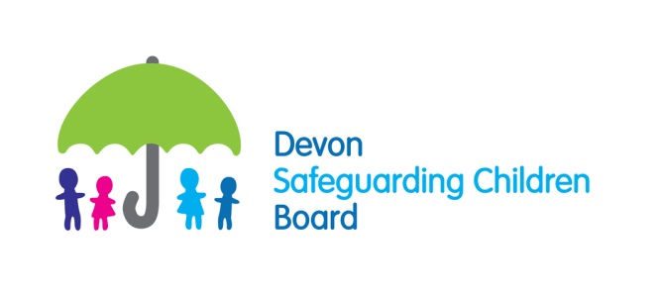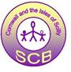

South West Peninsula
Learning & Improvement Framework

Appendix 4

Quality Assurance reporting schedule

MACA Timetable 2015:

DATE OF MACA | THEME | DATE REPORTING TO BOARD | DATE OF BEST PRACTICE FORUM
28th January 2015 | Looked after children | 11th March 2015
21st & 22nd April 2015 | Child sexual exploitation | 10th June 2015
15th & 16th July 2015 | Toxic trio (joint adult/children’s MACA) | 17th September 2015 | 13th October 2015
14th & 15th October 2015 | Working with sexual abuse | 9th December 2015 | January 2016

MACA Timetable 2016:

DATE OF MACA | THEME | DATE REPORTING TO BOARD | DATE OF BEST PRACTICE FORUM
20th & 21st January 2016 | Early Help | 9th March 2016 | April 2016 TBC
20th & 21st April 2016 |  | 8th June 2016 | July 2016 TBC
20th & 21st July 2016 |  | 14th September 2016 | October 2016 TBC
19th & 20th October 2016 |  | 14th December 2016 | January 2017 TBC

Section 11 process:

THROUGHOUT YEAR:

- Subgroup Feedback

- Executive monitoring of ongoing feedback

