Torbay
Safeguarding
Adults Board
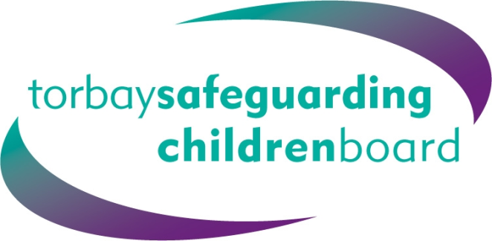

Managing Allegations of Historical Abuse

- Best Practice Guidance

Version 2: March 2015

Introduction
- Allegations of child abuse are sometimes made by adults and children many years after the abuse has occurred. There are many reasons for an allegation not being made at the time including fear of reprisals lack of trust in the justice system,, the degree of control exercised by the abuser, shame or fear that the allegation may not be believed. The person becoming aware that the abuser is being investigated for a similar matter or their suspicions that the abuse is continuing against other children may trigger the allegation.
- Recent national cases have highlighted some of the complex issues which underpin how historical allegations have previously been dealt with, prompting guidance for Prosecutors on how they should respond to such cases – guidance available here.
- These cases may be complex as the alleged victims may no longer be living in the situations where the incidents occurred or where the alleged perpetrators are also no longer linked to the setting or employment role. Such cases should be responded to in the same way as any other concerns. It is important to ascertain as a matter of urgency if the alleged perpetrator is still working with, or caring for children.

Significance
3. Organisational responses to allegations by an adult of abuse experienced as a child must be of as high a standard as a response to current abuse because:
  - There is a significant likelihood that a person who abused a child/ren in the past will have continued and may still be doing so;
  - Criminal prosecutions will still take place despite the fact that the allegations are historical in nature and may have taken place many years ago.
4. An allegation may be made against (for example) a foster carer, adoptive parent, residential care staff, teacher, doctor, police officer, volunteer or any other person who currently has, or previously had contact with children and young people. The alleged abuse may not have been an isolated incident and it may be part of a wider setting of institutional or organised abuse.
- Allegations involving professionals must be reported to the Local Authority Designated Officer (LADO) for the area in which the alleged abuse took place / where the professional worked, and the LADO procedures must be followed.

Action to Safeguard
6. As soon as it is apparent that an adult is revealing childhood abuse it is important to explain that relevant information may need to be shared with the police in order to safeguard children. If possible, establish if the adult is aware of the alleged perpetrators recent or current whereabouts and contact with children.
7. Whilst an adult service user should be asked whether s/he wants a police investigation it should be made clear that dependent upon the nature of the information provided the information may need to be shared with the police if it will help to protect children.
8. Consideration must be given to the therapeutic needs of the adult and reassurance given that, even without her/his direct involvement all reasonable efforts will be made to look into what s/he has reported.
9. The worker should:
  - Inform the police;
  - Contact Children’s Social Care in the area where the alleged incident took place

