Interactive Threshold Tool
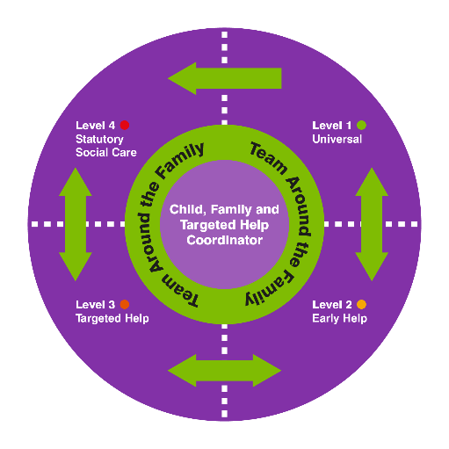
User Guide

On PC/ laptop:
Levels of need are listed at the left hand side of the screen, you can click on these for a definition of the level and drop down menus (circumstances and key features / Parent/ Carer capacity and engagement / Family and environment). Clicking on one of these headings takes you through to a page of indicators which can again be clicked on to provide information and links to services.
At the top of each indicator page there is a purple ‘related points’ button, clicking on this will bring up a box of related indicators up and down the threshold.

On mobile / I-pad:
A menu button on the top right of the screen gives access the list of levels, as above click on the levels to get the headings and then click through for the list of indicators. When you click on an indicator, the related points menu is a purple button on the right had side of the screen.

NB. If you spot any information that is out if date or anything that you feel is missing, please contact TSCB@torbay.gov.uk stating which level and indicator needs updating.

